**A FULL STACK DEVELOPMENT CAPSTONE PROJECT**



FoodBox

*(Source Code)*

* **Version History:**

|  |  |  |
| --- | --- | --- |
| 1. | **Author Name** | Devnath Tandi |
| 2. | **Purpose** | Source Code. |
| 3. | **Date** | 26 October 2022. |
| 4. | **Version** | 1.0 |
| 5. | **Contact** | [*devnath.g22@gmail.com*](mailto:devnath.g22@gmail.com) |

Contents.

1. User Flow Chart Diagram 3
2. GitHub Link… 4
3. Database Design… 4
4. Folder Structure… 6
5. Project Files… 11

# User Flow Chart Diagram.

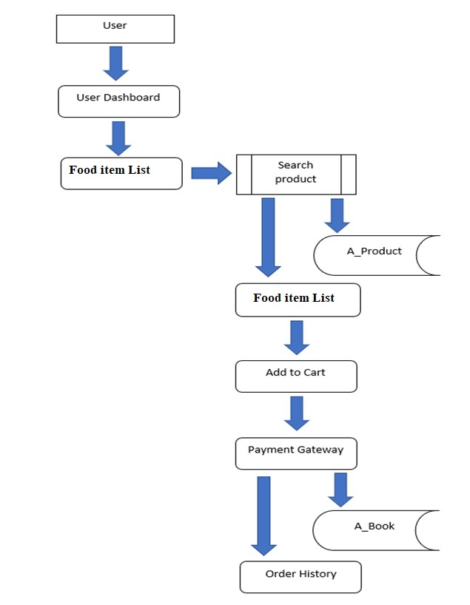

1. ***GitHub Link.***

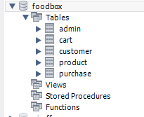

***3. Database Design.***

|  |  |
| --- | --- |
| **Repository Name.** | FoodBox-Capstone-Project |
| **GitHub Link.** |  |

Data Result Set:

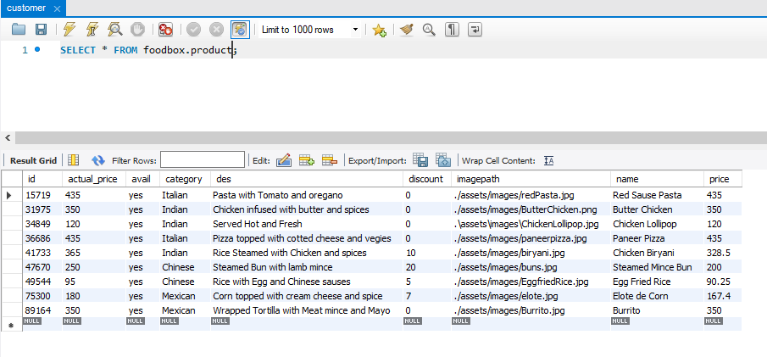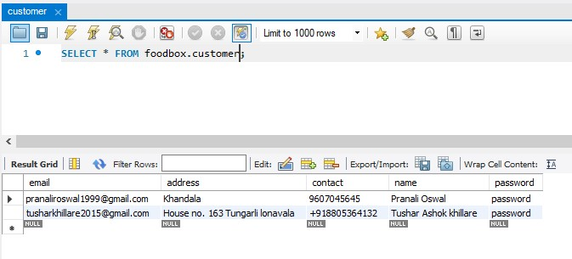

1. ***Folder Structure.***

**(Back End Development)**

Spring Project Structure

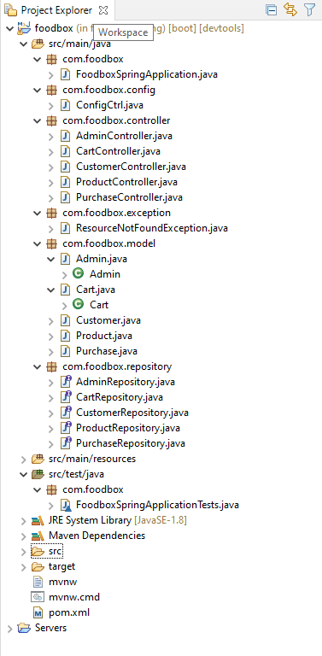

Pom.xml

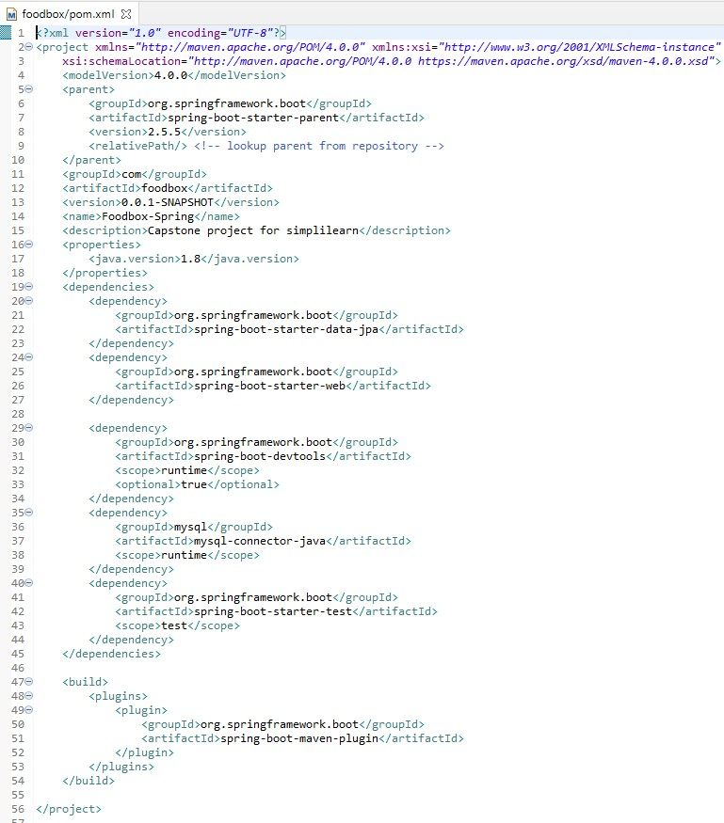

FoodSpringApplication.Java

FoodboxSpringApplicationTests.Java

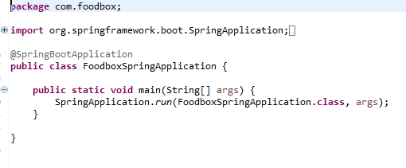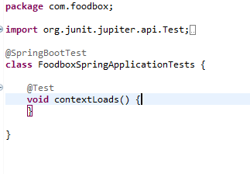

Rest of the files are present in the given GitHub link kindly refer this…

Spring Output:

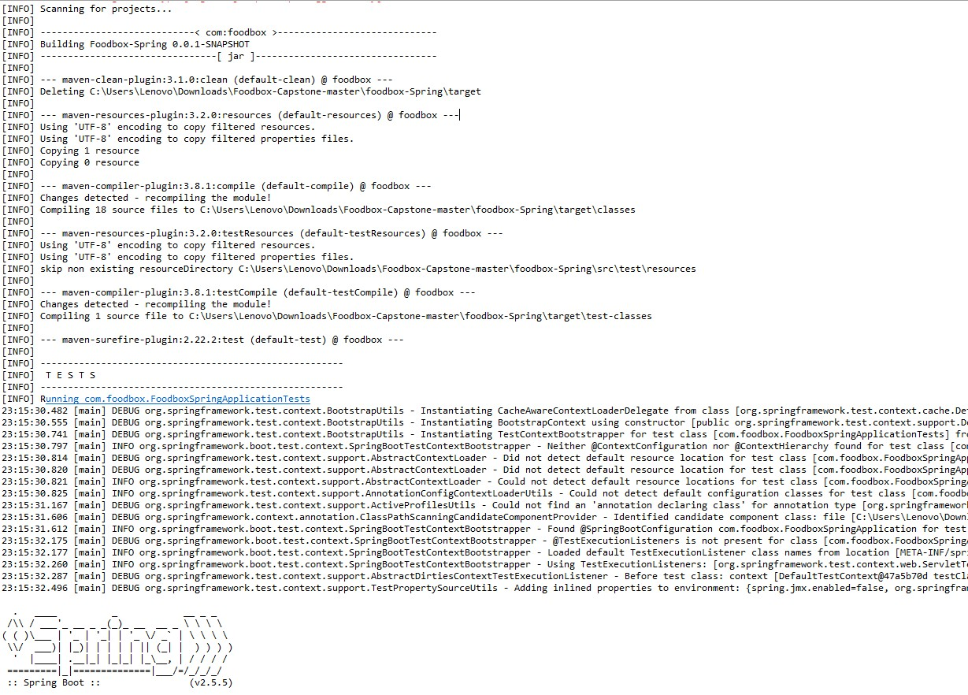

**(Front End Development)**

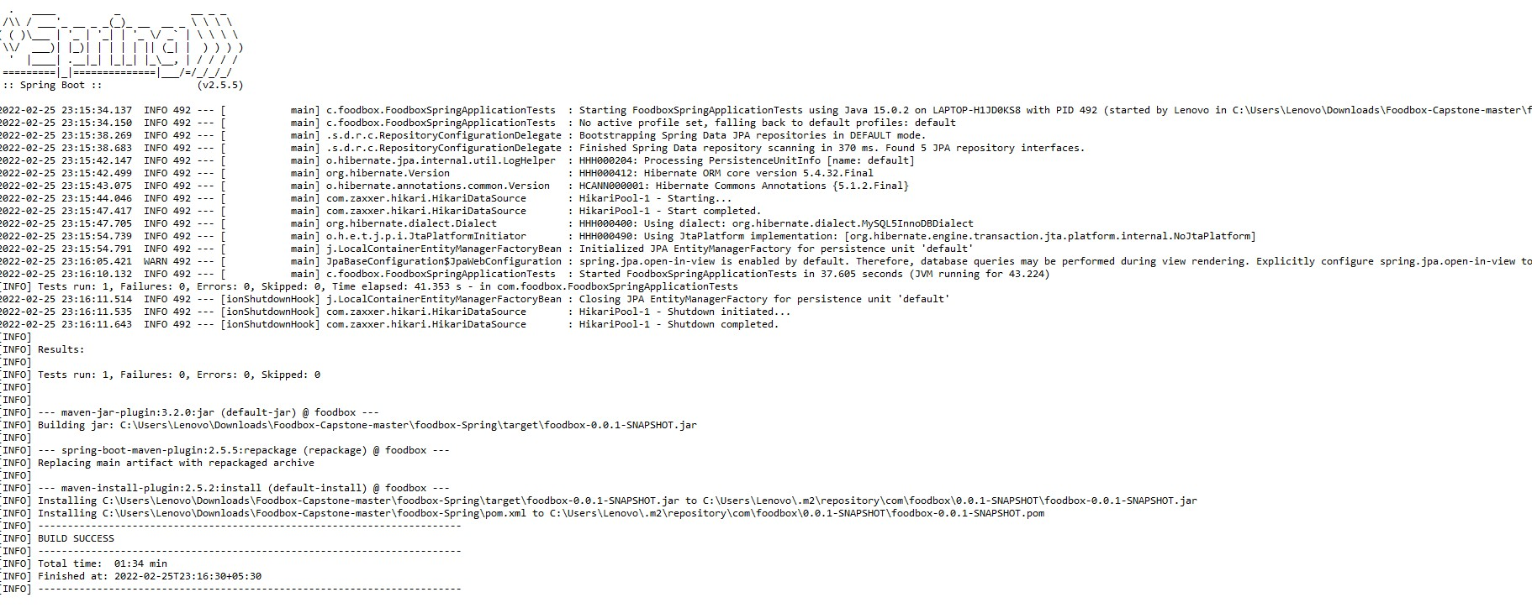

Angular Project Structure:

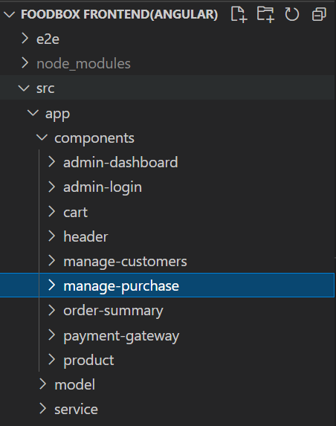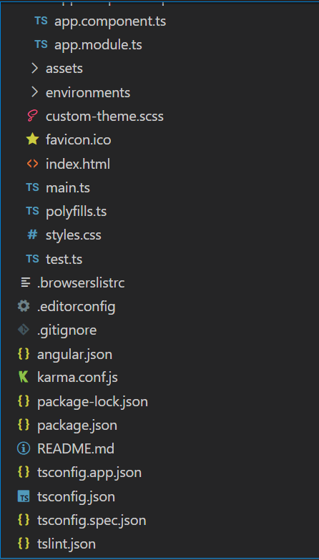

1. ***Project Files.***

Index.html

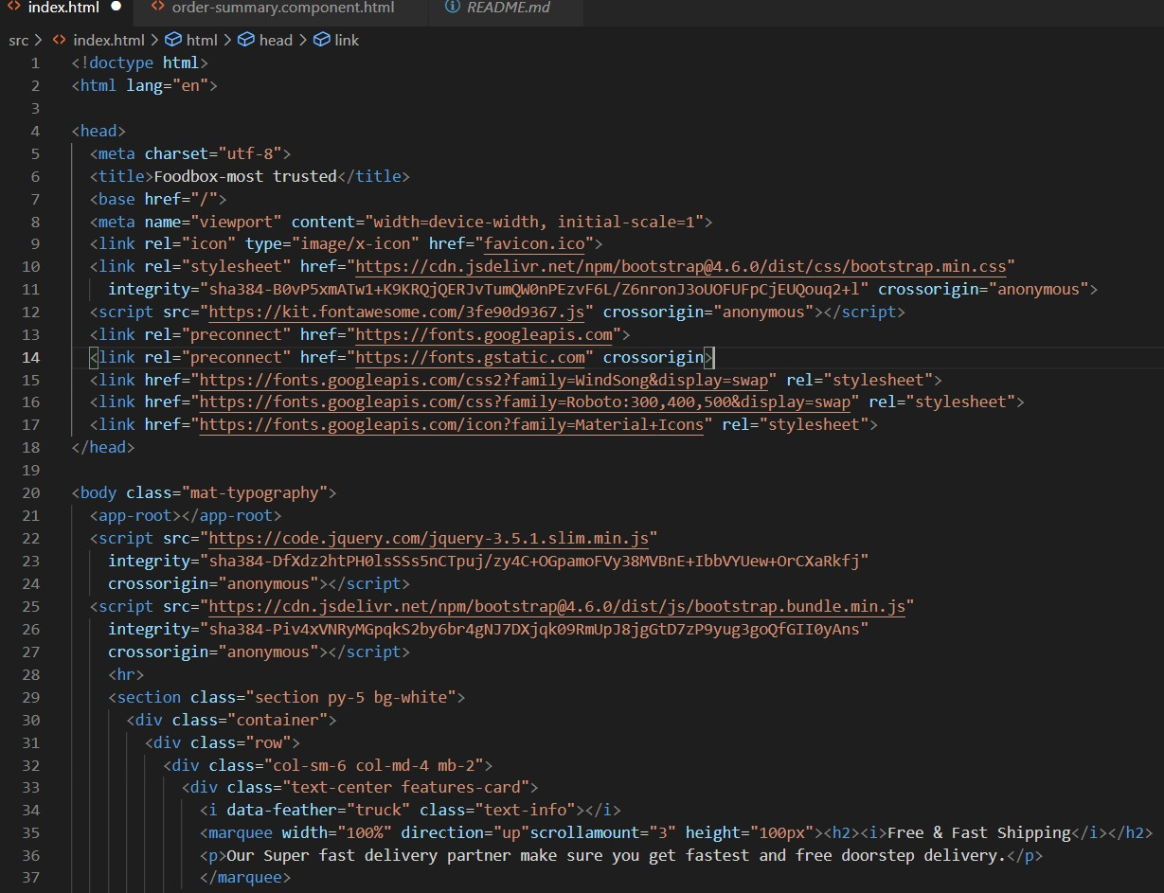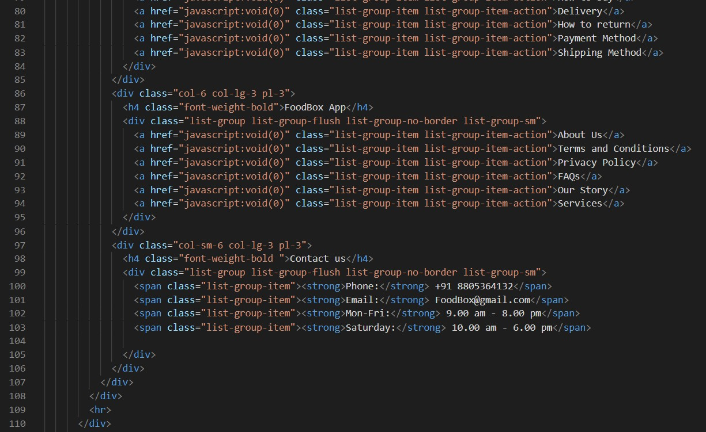

test.ts:

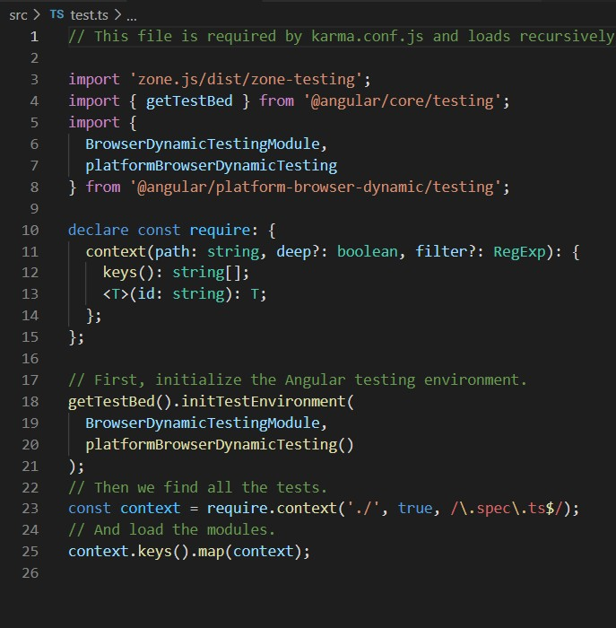

## Package.json:

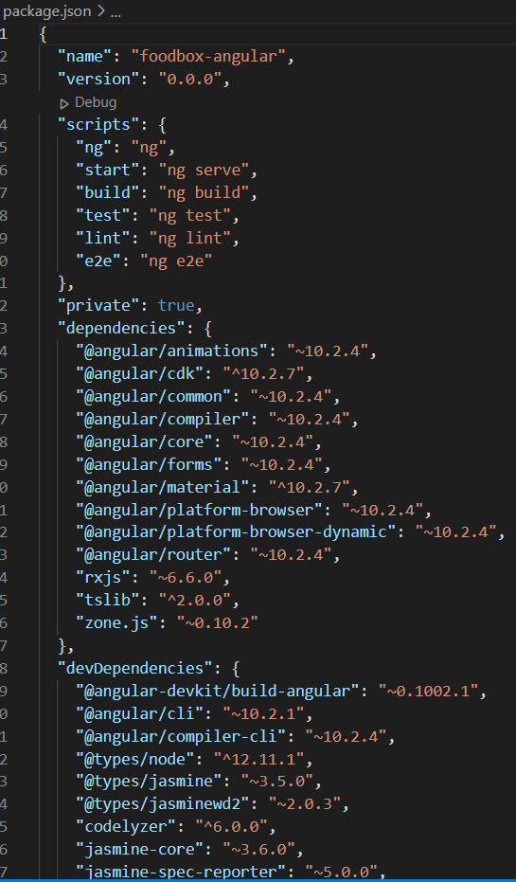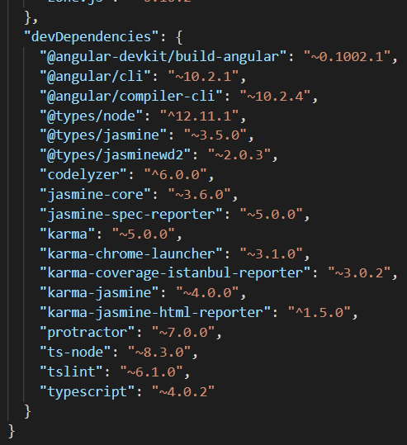

Angular Outputs:

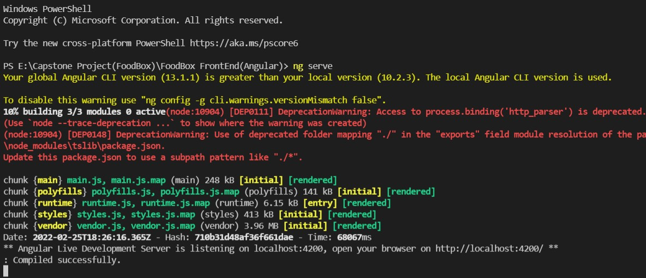

THANK YOU……………